# **Blockly modifications**

## **What is in progress**

Creating the connection blocks on field press - creating the connection blocks from a block

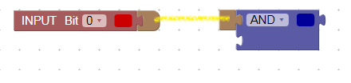

The ability of dragging the block without mouse pressed -   
 the solution is somewhere in gesture.js and touch_gesture.js

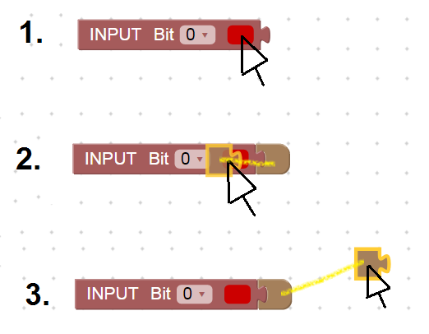

And future making the connection without the connector blocks